11.9: The torque due to 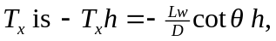and the torque due to 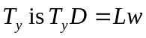. The sum of these torques is 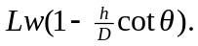From Figure (11.9(b)), 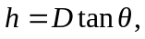so the net torque due to the tension in the tendon is zero.

